**PROJECT REPORT**

**1. INTRODUCTION :**

1.1 OVERVIEW :

First I created an **EMPATHY MAP** . A map has a four quadrant - Says Thinks , Does , and Feels . How to Analysize our housing prices in the metropolitan areas in India we will be say in quadrant . Next I created **BRAINSTROMING** . Our team take a problem statement is “people has how want to buy a house metropolitan areas in India , Then there are need what facilities in near by house they think”. Like this at all I created in brainstorming . Then I created my data analysis – Dashboard and Story. Next step I published my Dashboard and Story in Tableau public .

1.2 PURPOSE :

The purpose of the Housing prices is one of many economic indicators the investors use to keep a pulse on broader economic trends and potential shifts in the stock . The rise and fall of house prices can have big implecations for the economy . House price prediction can help the developer determine the selling price of a house and can help the customer to arrange the right time to purchase a house . Property prices in india are expected to increase 7.5 % on a pan- India basis this year .

**2. PROBLEM DEFINITION & DESIGN THINKING :**

2.1 EMPATHY MAP :

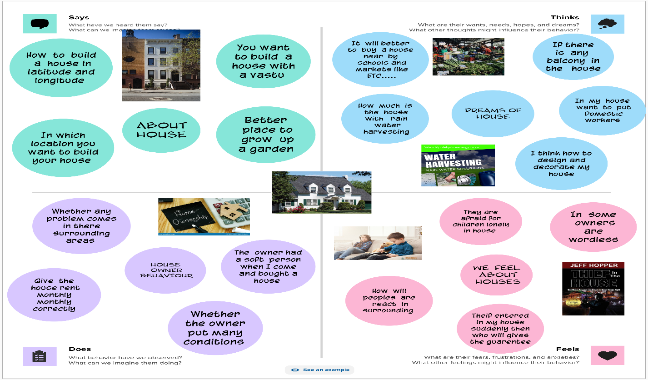

2.2 IDEATION & BRAINSTORMING MAP :

